**What do they need to DO?**

Four efficient inventory management techniques that guarantee top practises in your

company.

Included in the techniques are Just-in-Time

**GOAL** inventory management, downloading inventory software, lowering inventory carrying costs, and

successfully managing stock levels.

**What do they THINK and FEEL?**

**What do they SEE?**

Stock control that is efficient allows you to have

**What do they HEAR? PAINS GAINS** the right amount of stock in the right place at the

Employ more data sets. Excessive amount of less Sufficient amount right time.

ought should be more demanded stocks in the demanded stocks in the

efficient. store. store.

understanding of stock and

more room is needed for Inventory profit is the rise in an item's inventory management storing value that has taken place in stock

perroid and time

Stock predictions that are

Accurate stock forecasting successful must be profitable.

is difficult. to store a large enhancing the calibre of

amount of data goods and services

Lack of dedication, lack of Data analytics aids in decision-making

endurance, and lack of teamwork for a company.

**What do they SAY?**

Instruction to the team members.

What other thoughts and feelings might influence their behavior? Analysis of the stock

Store Display and Store Design and An inventory analysis should include

Presentation of Layout data on the amount of stock from one

Products period to the next.

Customer

Ambience of the Treatment Use more

Store data sets

**What do they DO?**

What do they do today?

What behavior have we observed?

What can we imagine them doing? Visit the Stores.

Analyze Promotional Activities.

Examine Gross Margin Trends.

by creating systems to log products, receive them into gathering precise data for a database.

inventory, track changes when sales occur, selecting efficient technology

manage the flow of goods from purchasing to final sale and check stock counts.

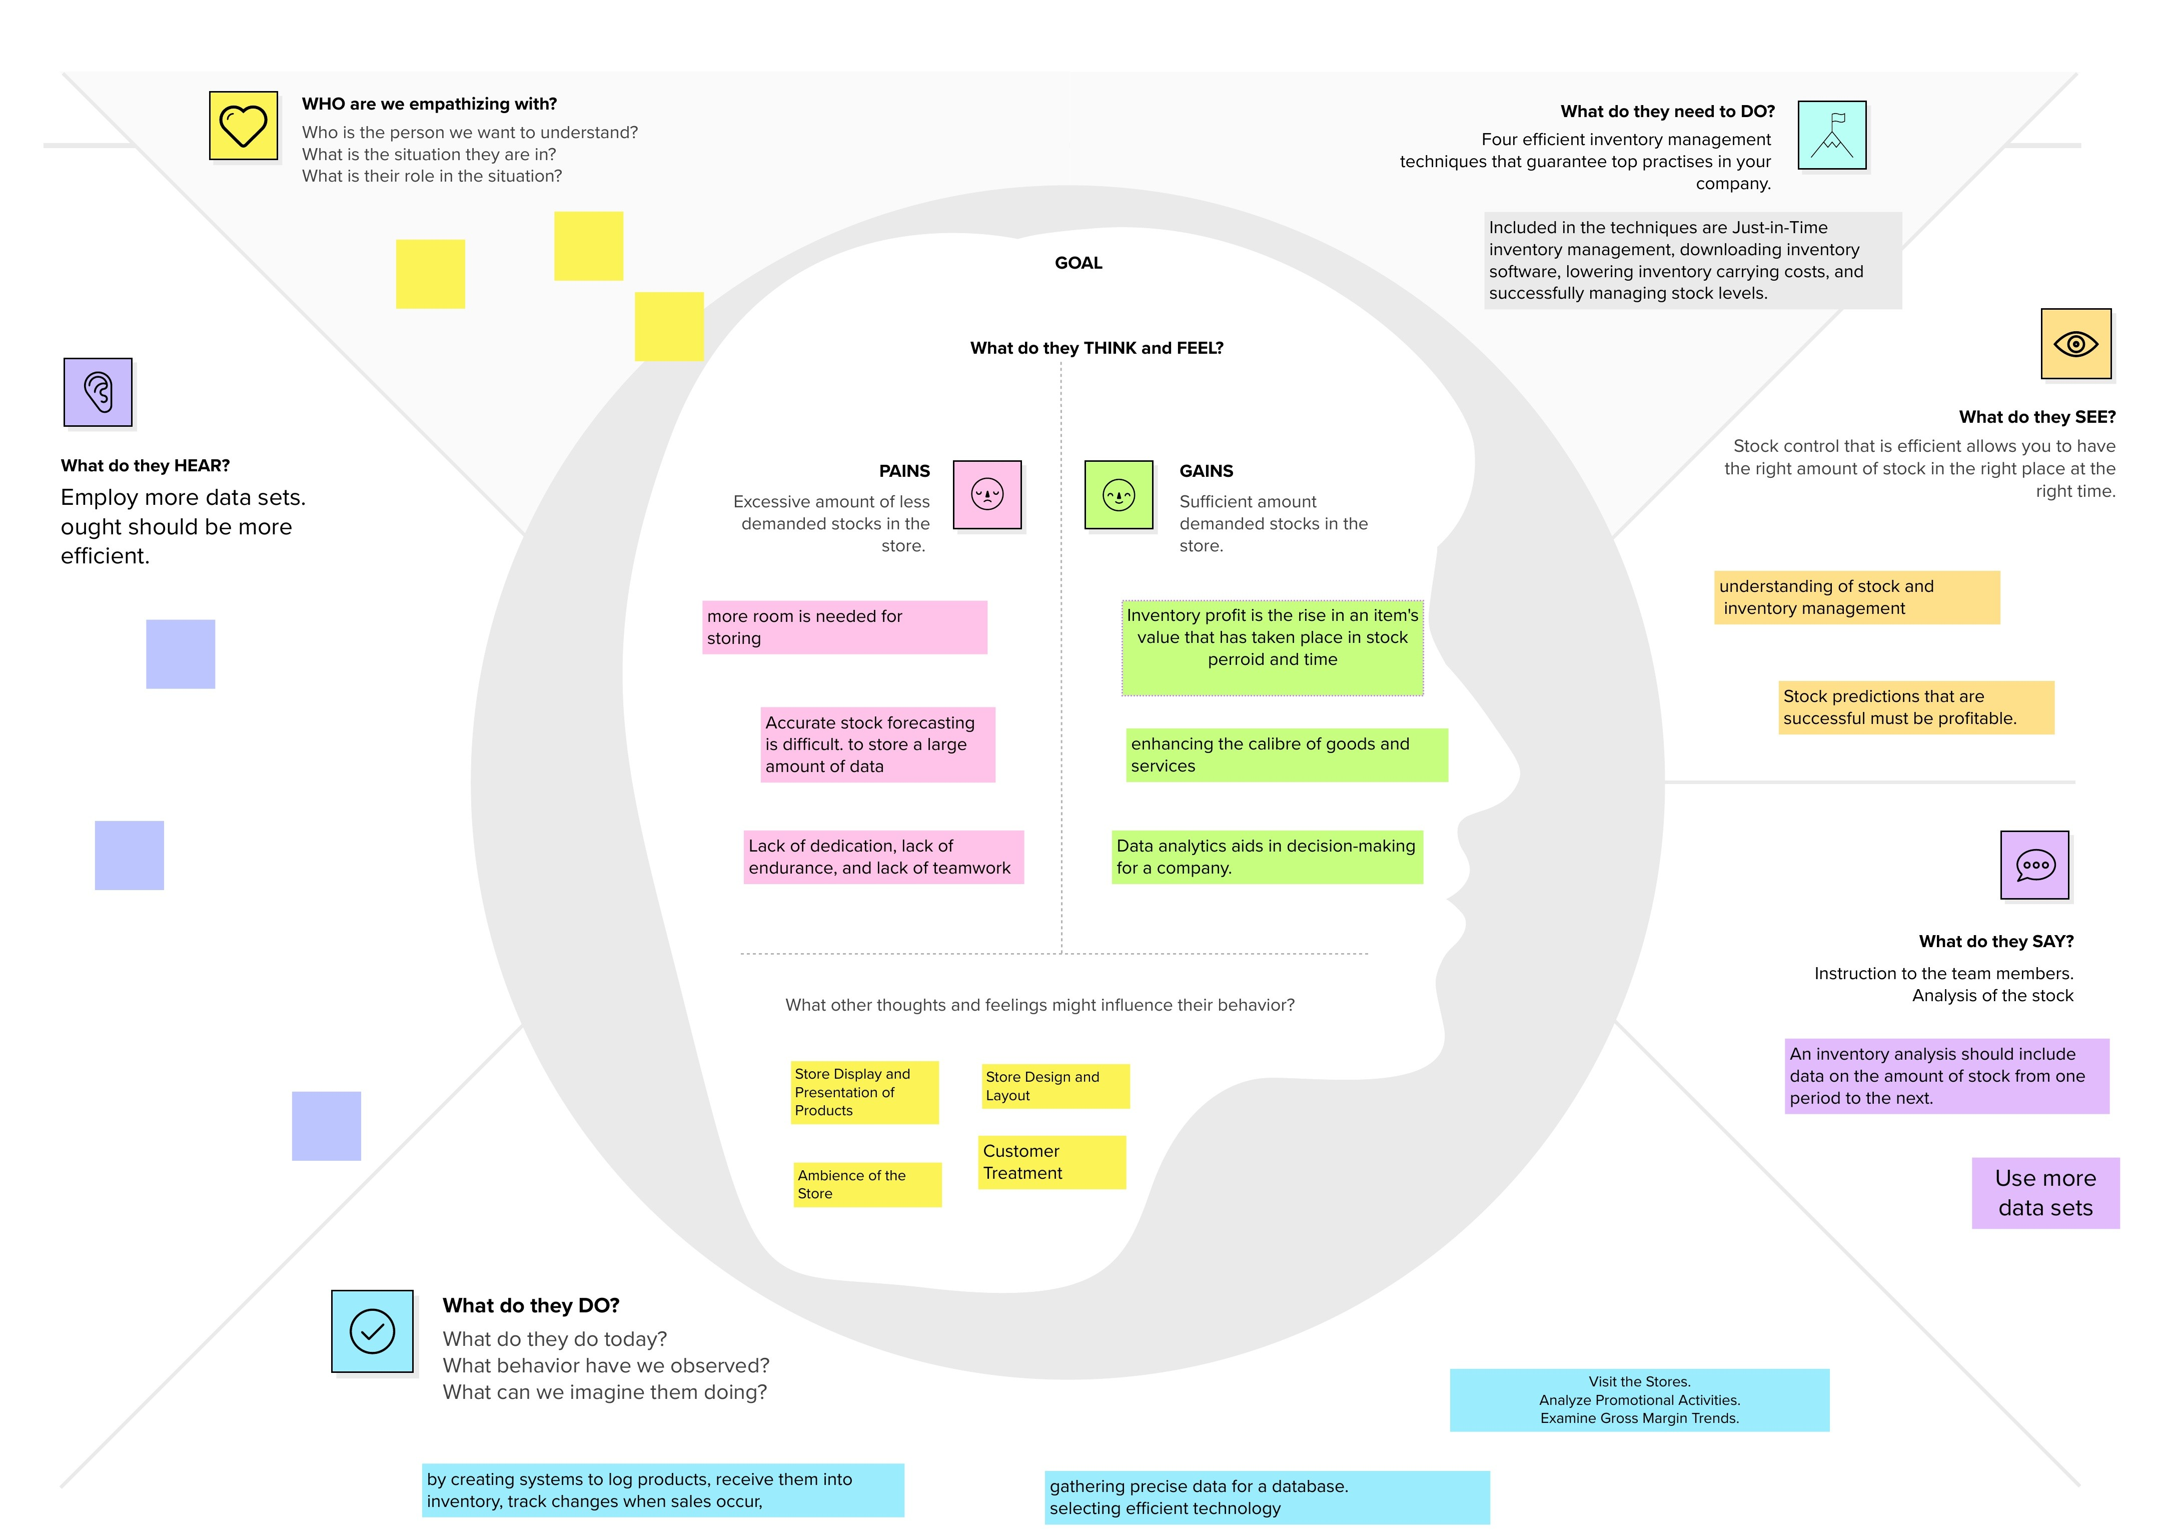

✴

Empathy map canvas

To Determine who are your most valuable clients.

Should be more effective

Need to be up-to- date

Is this safe and secure?

Frequently analysing the inventory

eliminate double ordering of stocks